1. Google Form for Food Delivery App Leads
Create a Google Form with the following fields:
- Full Name (Short answer)
- Email Address (Short answer)
- Phone Number (Short answer)
- Favorite Cuisine (Dropdown: Indian, Chinese, Italian, South Indian, Fast Food, Other)
Form Title: FoodExpress – Get Exclusive Offers!
Description: Sign up to receive launch discounts, free delivery offers, and updates.
You can create the form using:
Google Forms
Example Test Entry:
Field | Sample Data
Name | Rahul Patel
Email | rahulpatel@email.com
Phone | 9876543210
Favorite Cuisine | Italian
(Since I cannot create or submit a real Google Form from here, you can create it using the above structure and submit the sample entry.)

2. Landing Page Mockup (Zomato-Style Offer)
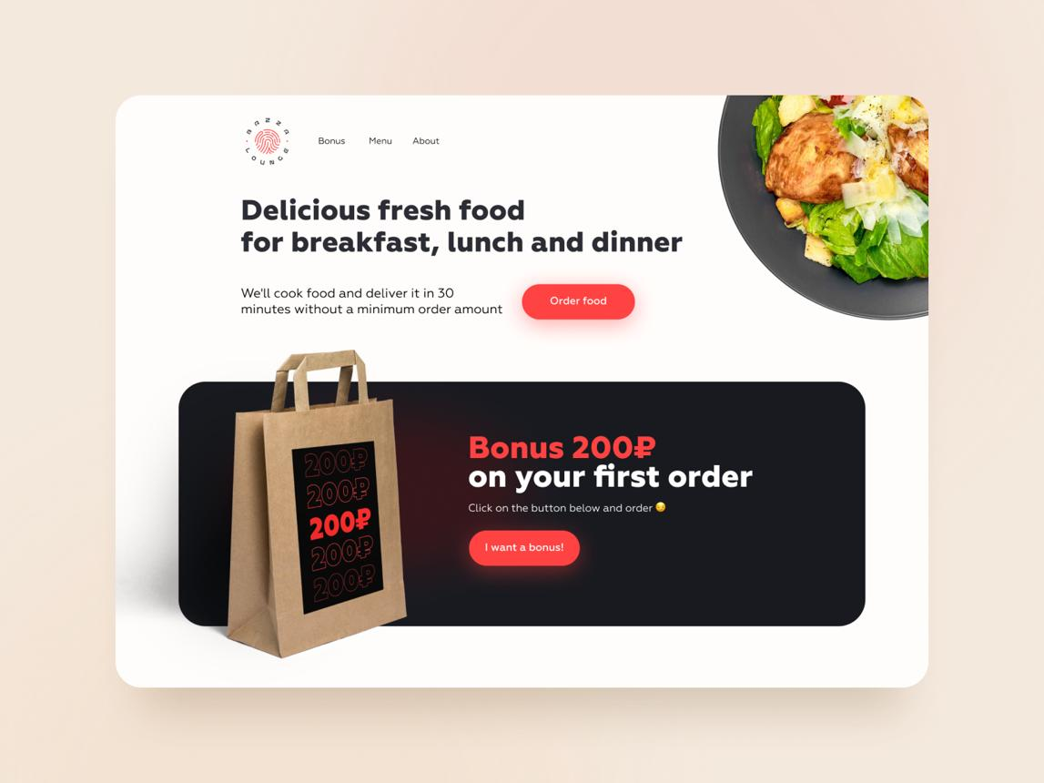
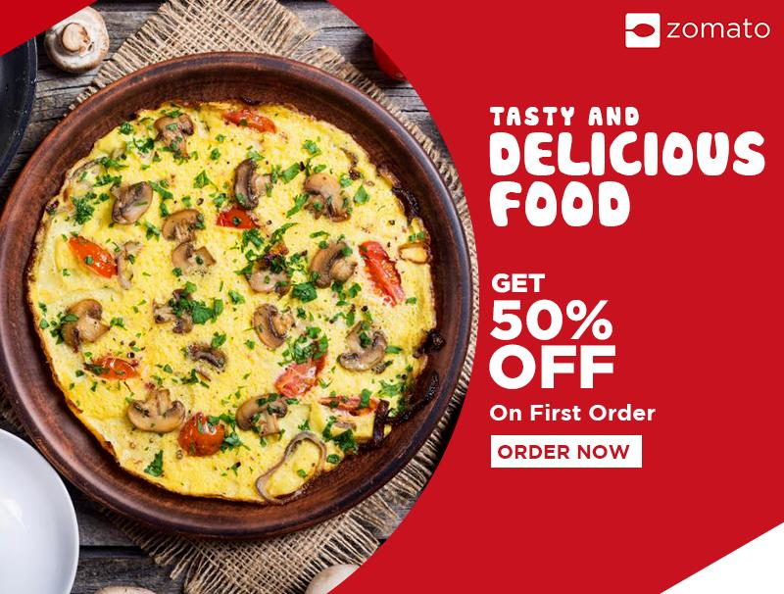
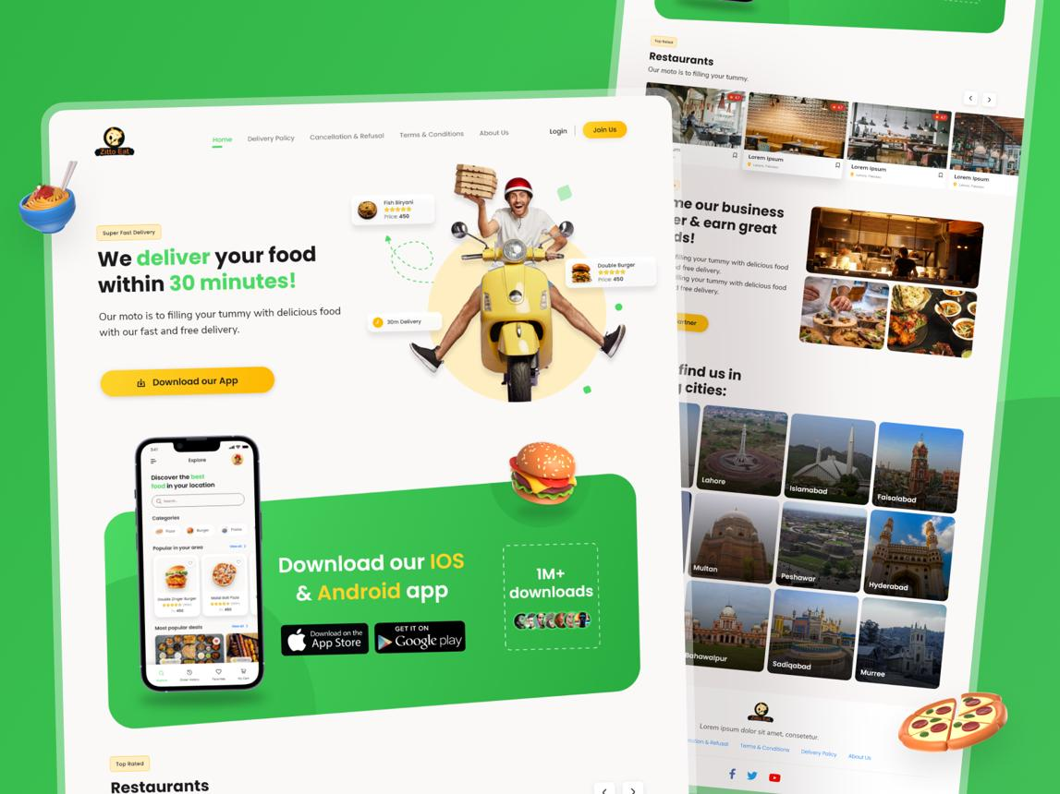
5
Landing Page Layout:
- Hero Banner:
🍔 Get 50% OFF on Your First 3 Orders!
- Subheading:
Sign up now and enjoy free delivery plus exclusive restaurant deals.
- Email Field:
[ Enter your email address ]
- CTA Button:
Claim My Offer
- Additional Elements:
  - Popular cuisines icons
  - Customer ratings
  - Limited-time offer countdown
You can design this using:
Canva or Figma

3. Lead Magnets for a Spotify-Style Music App
Lead Magnet | How It Collects User Information
30-Day Free Premium Trial | Users provide email and account details to activate the trial.
Exclusive Celebrity Playlist Access | Users sign up with email to unlock special playlists.
20% Premium Subscription Coupon | Users submit contact details to receive the discount code.

4. WhatsApp Follow-Up Message
Hi [Name] 👋,
Thank you for showing interest in our IPL Fantasy League app! 🏏
Create your team, compete with friends, and win exciting rewards this season.
👉 Download the app and join now: [App Link]
Let us know if you need any help getting started. Good luck! 🎉

5. Catchy Headlines for a Flipkart-Style Electronics Sale
- Get Early Access to the Biggest Electronics Sale of the Year!
- Sign Up Now & Unlock Exclusive Deals on Mobiles, Laptops, and More!
- Be First in Line for Massive Discounts on Top Gadgets!
- Join Today and Receive VIP Access to Limited-Time Tech Offers!
- Register Now to Grab Unbeatable Prices Before Everyone Else!

